

DIOCESE OF HEXHAM & NEWCASTLE

## **St Michael’s Catholic Primary School**

## **Within Bishop Bewick Catholic Education Trust**

## Clumber Street North, Elswick,Newcastle upon Tyne, NE4 7RE

## Tel. 0191 2739383

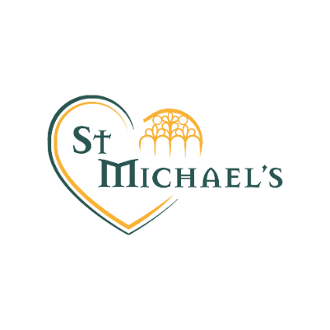

### ADMINISTRATIVE ASSISTANT LEVEL 2 Grade BB03

**20 hrs per week term time only plus 3 training days**

**Required May 2024**

Salary £22,737 per annum pro rata, Actual £10,447 per annum

20 hours per week , term time plus 3 training days

*This post attracts a Living Wage supplement. In addition to the hourly rate, this post will receive the Living Wage supplement to bring the hourly rate up to a minimum of £12 an hour.*

Fixed term until 31 August 2025

We are looking to appoint an Administration Assistant for reception, general office duties and to support the current Administration team. Working pattern is Monday to Friday 8.30am – 12.30pm

Applications must be made on CES forms which are available from the school's website and submitted by the closing date for the attention of the Executive Headteacher, Mrs C Chapman at the above address.

St Michael’s Catholic Primary school is committed to safeguarding and promoting the welfare of children, young people and vulnerable adults and expects all staff and volunteers to share this commitment. Successful applicants will be required to obtain an Enhanced Certificate of Disclosure from the Disclosure and Barring Service.

**Closing Date:**  **12 noon on 13th May 2024**

**Interviews:** **W/B 20th May 2024**

This school is strongly committed to safeguarding and promoting the welfare of children and young people. Successful applicants will be required to obtain an enhanced certificate of disclosure from the Disclosure and Barring Service and a range of recruitment checks.