St Michael’s Sporting News 2021/22

Dear Parents and Carers,
Welcome to our annual sports letter which will detail all of our outstanding sporting achievements each year. We have very talented children at St Michaels who always give 100% in any sport they compete in. This is the first full year of sport we have been able to complete since 2019. Here are some of our successes.
Football:
The girls football team have enjoyed a mixed season of football. For some of the girls, it was the very first time they had played football so should be proud of themselves. The girls competed well in the West Newcastle league finishing and finished a respectful 7th in a very tough league. They also, competed in the county cup and went out at the hands of eventual winner Ovingham Middle school. Well done girls, continue to play and enjoy it.
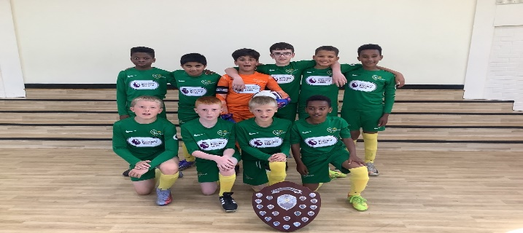
The boys football team had a season to remember. A record-breaking season, where they made it to four cup finals which is a fantastic achievement. In the Westgate league, they went unbeaten all season, playing 12, winning 12 only conceding 3 goals. What a great achievement! This resulted in qualification for the King’s cup which is contested by the four league winners in Newcastle. On the night, we finished runners up – again a great achievement for our school. Next, they played in the prestigious Bishops cup. They played some of the larger Catholic Primary Schools in the Diocese and produced some excellent football throughout resulting in qualifying for the final. A first for our school. On the night, they played in some extreme heat a topped their group meaning they qualified to play for the trophy. In the trophy game, they did not get the rub of the green and lost a close game. Runners up in the whole of Hexham and Newcastle diocese. WOW! Up next was the end of season catholic cup, some excellent football resulting in qualifying for the final. Again, a first for our school. Unfortunately, losing in the final on penalties to St Teresa’s. Finally, the catholic city cup, played at the Newcastle United academy brought the curtain down on a season which will take some beating. The boys were outstanding from the very first whistle and dominated the game running out 4-1 winners against St Charles, Gosforth.
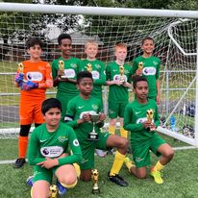

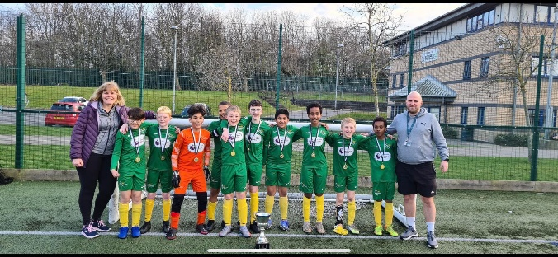

Hockey:
Throughout this academic year, hockey has continued to be a sport thoroughly enjoyed by both boys and girls at St Michael’s. Due to the success of the hockey club last academic year, the school ran another oversubscribed hockey club in the across the year- much to the delight of the children! In addition, due to the success of the club, the school PE team decided to enter a team into the year 5/6 school sports games hockey competition - this gave the children the incentive to practice and develop their skills even more - with some boys and girls even purchasing their own hockey stick! Outstanding teamwork and skill meant they produced some excellent results against more known hockey school and qualified to represent the city at the county finals. What a great achievement! At the finals, we competed gallantly against some highly skilled teams and finished 3rd in our group. This meant we bowed out to competition at the group stage, still a fantastic achievement for the boys and girls and our school
Nonetheless, we will continue in our efforts at St Michael’s to raise the profile of hockey and offer opportunities for our children to take part in a variety of sports in addition to those already offered.
Netball:
Another relatively new sport to St Michaels is Netball. The boys and girls have taken part in Netball in PE but not an actual competition. It took a while during the first game to adjust to Netball as they are such talented Basketball players, but due to their athletic skill and determination they quickly picked up games rules and produced some excellent displays of Netball. Unfortunately, we lost 3 and drew 1 and won 1 during the group stage meaning we bowed out of the competition but for some it was the first time playing any sport competitively and they showed great teamwork and spirit throughout. Well done team!
Other sports:
We also competed in many other sports such as athletics, quadkids and the balance bike derby where we competed with respect and great skill. We will continue to enter competition so we can showcase the talents our children of St Michael’s have.

Athletes of the year:
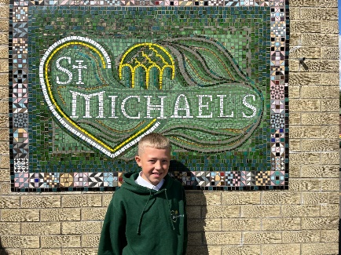
Male Athlete – Stephen Brayson
Stephen is an outstanding athlete who can put his hand to most sports he tries. Stephen was an integral part of the history making school football team scoring many vital goals across the season. He was also part of the successful hockey team which represent Newcastle city at the county finals. He has great control, hand-eye co-ordination and most of all desire to win and support his team mate. Keep it up in the future Stephen and you will go far!

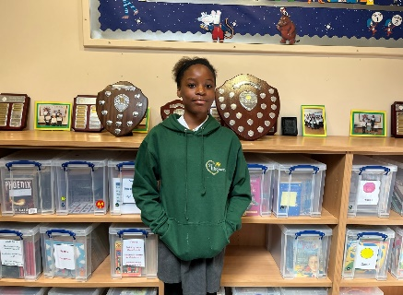
Female Athlete – Stephanie Oghogho Anthony
Stephanie has performed excellently in everything she has competed in. She was a part of the girl’s cricket team which performed very well in their first ever cricket matches. Stephanie was also a part of the netball team which played some great technical netball, she showed great movement and the ability to find pace to receive the ball. Her best achievement was finishing 13th overall in the city in the city cross country championships, what a great achievement Stephanie! Keep up the running – you have a real talent for it!

I hope you have enjoyed reading about the sporting successes of St Michael’s and keep an eye out on the school website, Facebook and Twitter pages for the sporting achievements for 2022/23.
Thank you,
Mr Gorman

